Bolton-by-Bowland C E Primary School - Pupil Performance Data 2024
Key Stage 2 Results
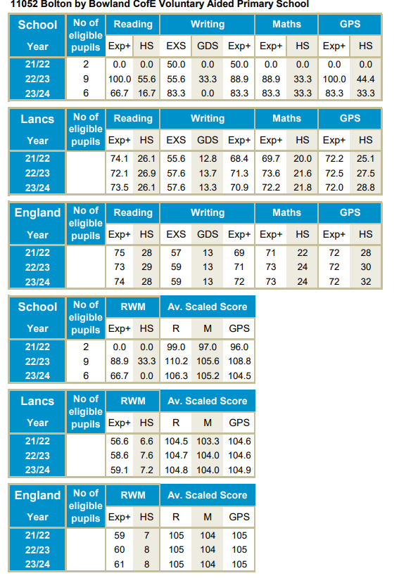

Key Stage 1 Results
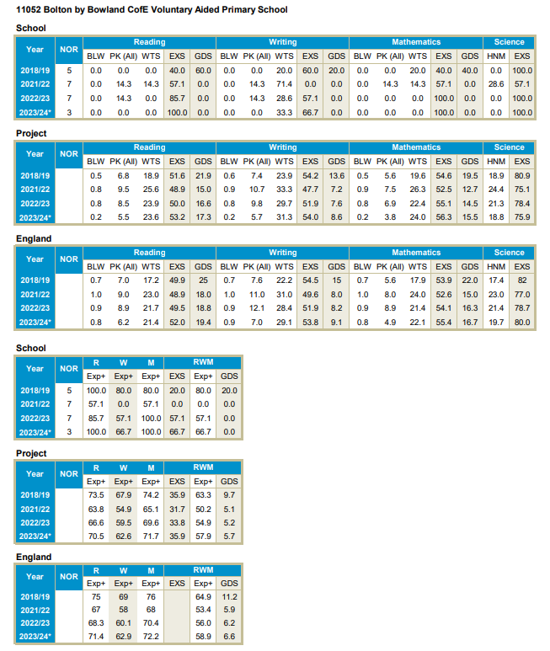

Early Years Foundation Stage Profile (EYFSP)
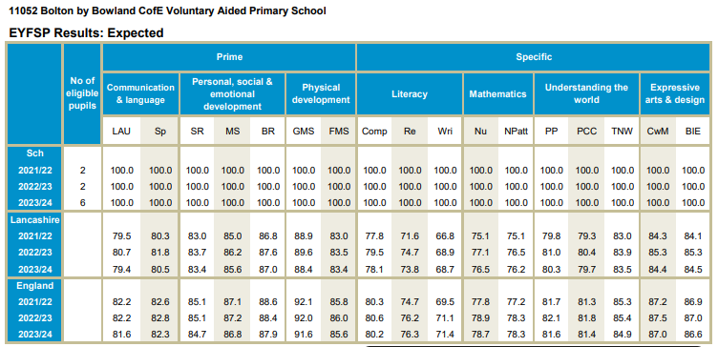
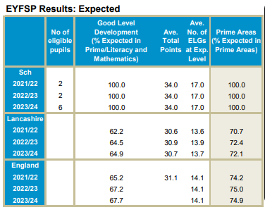
Year 1 Phonics



