KS2 Outcomes 2023

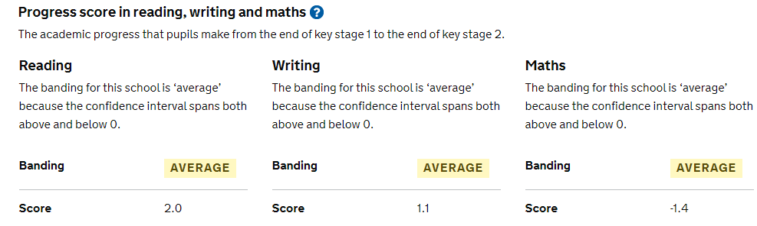

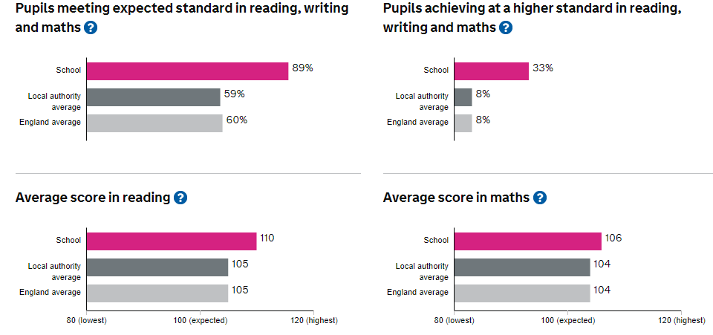

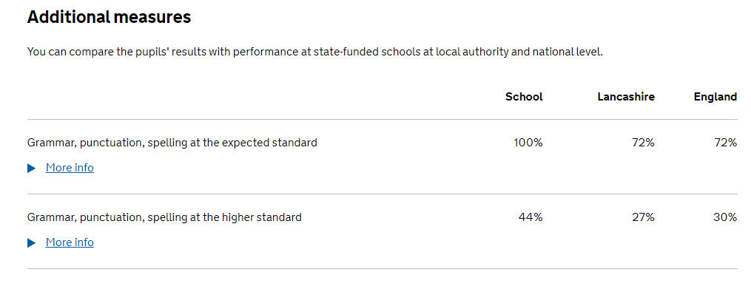

KS2 Pupil Outcomes
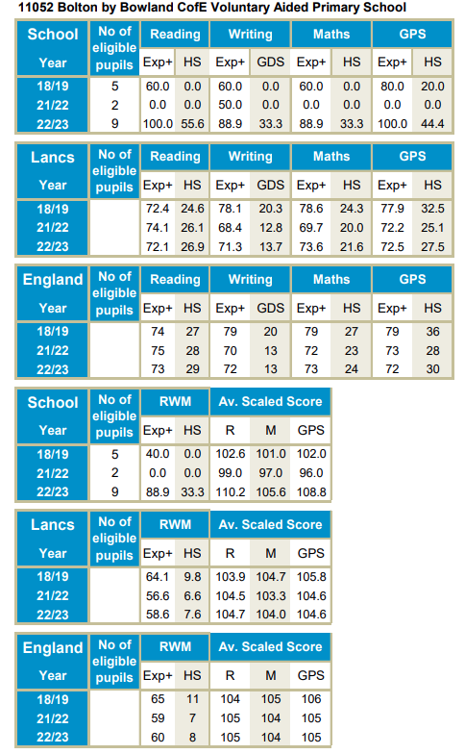

Early Years Outcomes 2023

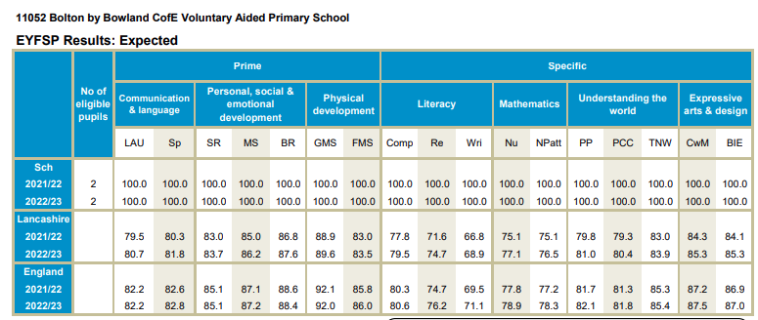

KS1 Outcomes 2023
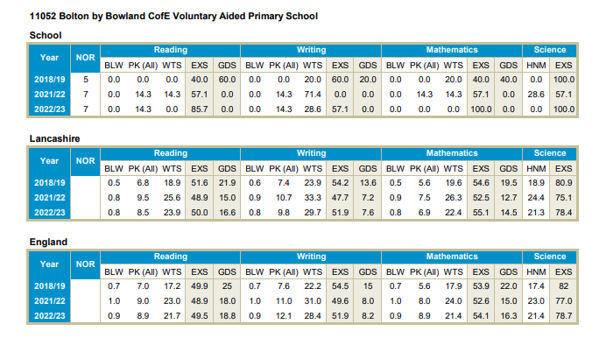
Note: EXS is expected level and GDS is exceeding expected level

Year 1 Phonics Screening 2023
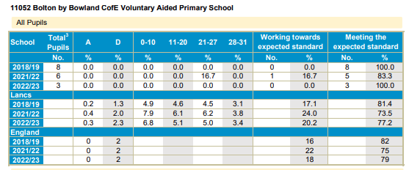
Year 2 Phonics Screening 2023


