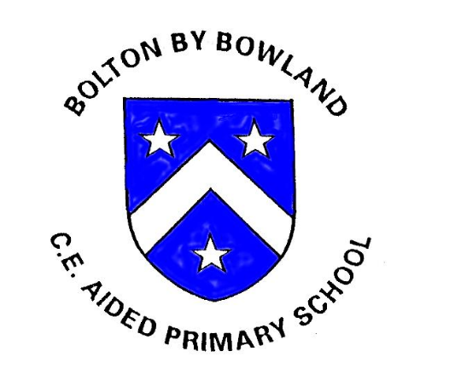

Science Policy
Date Approved: November 2025
Review Date: November 2028
Review Cycle: 3 years
Science Lead: Lisa Francis
Vision Statement
In our school, we belong to each other and to God. We all feel welcome, valued and accepted for who we are.
We believe in ourselves and each other as we grow in confidence and skills every day.
We are all special in our own way, using the gifts that God has given us. We are blossoming into the kind, respectful, hardworking and trustworthy people that God wants us to be.
Belong Believe Blossom

1. Introduction
At Bolton-by-Bowland CE Primary School, we recognise the importance of science in developing pupils’ curiosity about the world around them and helping them to understand how scientific ideas shape our lives. This policy outlines the school’s approach to teaching and learning in science and reflects our commitment to providing high-quality science education that is accessible, engaging and ambitious for all pupils.
As a small, rural primary school with mixed-age classes, our science curriculum is designed to ensure clear progression in knowledge and skills while allowing flexibility to meet the needs of all learners.

2. Intent
Our intent is to inspire curiosity, foster a sense of wonder and develop pupils’ understanding of the world through the disciplines of biology, chemistry and physics. We aim to equip pupils with the scientific knowledge, enquiry skills and vocabulary they need to ask questions, think critically and understand the relevance of science in everyday life.
We want pupils to develop a strong foundation of substantive knowledge alongside the ability to work scientifically, enabling them to plan investigations, make observations, record findings and draw conclusions. Our curriculum is designed to ensure that scientific knowledge and skills build progressively over time, with opportunities for pupils to revisit and deepen their understanding.
Our science curriculum aims to ensure that all pupils:
- develop curiosity and enthusiasm for science
- acquire key scientific knowledge across biology, chemistry and physics
- use scientific vocabulary accurately and confidently
- develop enquiry skills through practical investigation and exploration
- understand how science relates to the world around them and to future careers

3. Implementation

3.1 Curriculum Organisation and Planning
Science is taught using the Developing Experts scheme, which provides a structured, progressive and knowledge-rich curriculum aligned to the National Curriculum. The scheme supports clear progression in both substantive knowledge and disciplinary skills, making it well suited to teaching science within mixed-age classes.
In mixed-age classes, long-term planning ensures full coverage of the National Curriculum over a two-year rolling programme. Content is carefully selected and adapted to ensure progression, challenge and accessibility for all pupils, regardless of age or starting point. Key knowledge is revisited and built upon, allowing pupils to deepen their understanding over time.

3.2 Teaching and Learning
Lessons are designed to be engaging, practical and enquiry-based wherever appropriate. Pupils are encouraged to ask questions, make predictions, carry out investigations and reflect on their findings. Teachers use Developing Experts resources to support high-quality explanations, accurate scientific vocabulary and clear modelling of scientific concepts.
Working scientifically is embedded throughout the curriculum, with pupils developing skills such as:
- observing closely
- asking questions
- planning and carrying out investigations
- recording results
- interpreting data
- drawing conclusions
Opportunities are provided for pupils to work independently, collaboratively and through practical experiences, helping them to develop confidence and resilience as young scientists.

3.3 Assessment
Assessment in science is ongoing and used to inform teaching and learning. Formative assessment takes place during lessons through questioning, observation, discussion and pupil work.
The Developing Experts assessment tools are used to support teacher judgement and monitor pupils’ understanding of key concepts and vocabulary. Assessment outcomes are used to:
- identify gaps or misconceptions
- inform planning and adapt teaching
- ensure progression in knowledge and skills
- support subject leader monitoring

3.4 Inclusion and Differentiation
All pupils have access to the science curriculum. Lessons are adapted and scaffolded to meet the needs of all learners, including pupils with SEND and those requiring additional challenge. In mixed-age classes, differentiation ensures that pupils can access learning at an appropriate level while being challenged to achieve their full potential.

4. Impact
The impact of our science curriculum is that pupils leave Bolton-by-Bowland with a secure understanding of key scientific concepts and the ability to think and work scientifically. They are curious, confident learners who can ask questions, investigate the world around them and explain their ideas using appropriate scientific vocabulary.
Pupils demonstrate:
- secure and developing scientific knowledge
- confidence in carrying out investigations
- accurate use of scientific language
- enthusiasm and curiosity about science
- readiness for the next stage of their education
Assessment outcomes and pupil work show that pupils make good progress from their starting points and are well prepared for secondary science education.

5. Equal Opportunities and Inclusion
We are committed to providing equal opportunities for all pupils to access and succeed in science. Teaching and learning are inclusive and reasonable adjustments are made to ensure that all pupils can participate fully in science lessons and practical activities.

6. Monitoring and Review
The Science Subject Leader is responsible for monitoring the effectiveness of this policy through lesson observations, work scrutiny, pupil voice, assessment analysis and staff feedback. The policy will be reviewed in line with the school’s policy review cycle.
Next Review Date: November 2028
Approved by Governing Body:

