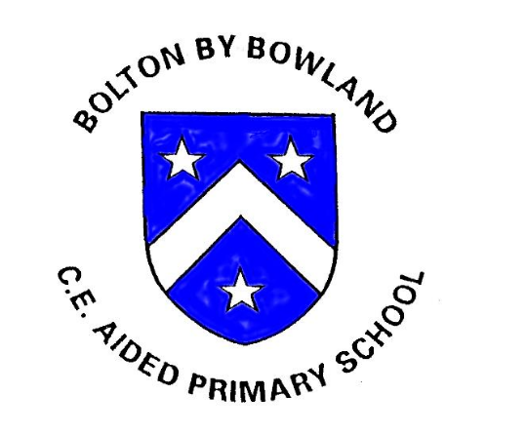

Phonics Policy
English Lead: Joanne Abram
Date Approved: September 2025
Review Date: September 2028

Intent
At Bolton-by-Bowland CE Primary School, we believe that the ability to read is fundamental to children’s success across the curriculum and in later life. We aim to ensure that all children become fluent, confident readers by the end of Key Stage 1 through the systematic teaching of phonics.
To achieve this, we follow Little Wandle Letters and Sounds Revised, a validated systematic synthetic phonics programme. This programme provides a consistent, structured and inclusive approach to teaching early reading and spelling.

Aims
Through the delivery of Little Wandle Letters and Sounds Revised, we aim to:
- Develop early reading and spelling skills through daily phonics teaching
- Ensure all children learn to decode fluently and apply phonics knowledge confidently
- Foster a love of reading and enjoyment of books
- Close gaps quickly for children at risk of falling behind
- Ensure consistency and progression across EYFS and Key Stage 1

Implementation

Phonics Teaching
- Phonics is taught daily in EYFS and Key Stage 1 using the Little Wandle scheme
- Sessions are fast-paced, engaging, and structured
- Children are taught to:
  - Recognise graphemes and match them to phonemes
  - Blend sounds to read words
  - Segment sounds to spell words
- Teaching follows the progression and structure outlined in the Little Wandle programme

Early Years Foundation Stage (EYFS)
- Phonics teaching begins in Nursery with Phase 1 phonics and then in earnest in Reception once children are ready
- Daily sessions follow the Little Wandle progression
- Children practise phonics through:
  - Adult-led sessions
  - Continuous provision
  - Shared and guided reading

Key Stage 1
- Daily phonics sessions continue in Year 1 and Year 2 as required
- Children move from learning to decode to developing fluency and comprehension
- The programme supports preparation for the Year 1 Phonics Screening Check
Reading Practice Sessions
- Children take part in three weekly reading practice sessions
- Books are fully decodable and closely matched to each child’s phonics knowledge
- Sessions focus on:
  - Decoding
  - Prosody (reading with expression)
  - Comprehension
Children take home a matched reading book to ensure success and confidence.

Assessment and Tracking
- Children’s progress is assessed regularly using:
  - Ongoing formative assessment
  - Half-termly Little Wandle assessments
- Assessment outcomes are used to:
  - Identify children at risk of falling behind
  - Inform planning and intervention
  - Ensure appropriate book matching

Intervention and Support
- Any child who is identified as falling behind receives daily keep-up interventions
- Interventions are:
  - Timely
  - Short
  - Closely matched to classroom teaching
- Children in Key Stage 2 who require additional phonics support will receive targeted intervention using Little Wandle materials where appropriate

Inclusion and Equal Opportunities
The Little Wandle programme is inclusive and supports:
- Children with Special Educational Needs and Disabilities (SEND)
- Children requiring additional phonics practice
Adaptations and additional support are provided as necessary to ensure all children can access phonics learning.

Staff Training and Support
- All staff involved in phonics teaching receive regular training
- Practice is monitored through:
  - Lesson observations
  - Coaching and feedback
  - Pupil progress meetings
- Staff are supported to ensure consistent delivery of the programme

Parental Engagement
We work in partnership with parents and carers by:
- Providing information sessions on phonics and reading
- Sharing guidance on how to support reading at home
- Ensuring home reading books are matched to classroom learning

Monitoring and Review
- The Phonics Leader monitors the teaching and learning of phonics
- This policy is reviewed to reflect best practice and programme updates

