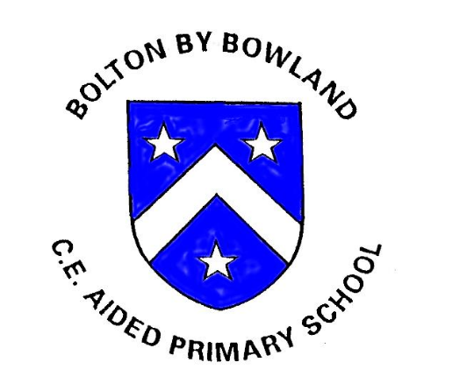

Bolton-by-Bowland C E Primary School

English Policy

English Lead: Joanne Abram
Date Approved: September 2025
Review Date: September 2028
Review Cycle: 3 years
Policy Owner:

1. Introduction
At Bolton-by-Bowland CE Primary School, we recognise that English is fundamental to pupils’ success across the curriculum and in everyday life. This policy outlines the school’s approach to the teaching and learning of English, including reading, writing, phonics and spoken language and reflects our commitment to high standards of literacy for all pupils.
As a small, rural primary school with mixed-age classes, our English curriculum is designed to ensure clear progression, inclusivity and high expectations, while meeting the needs of all learners.

2. Intent
Our intent is to ensure that all pupils develop the skills, knowledge and confidence to communicate effectively through reading, writing and spoken language. We aim to foster a lifelong love of reading and writing whilst equipping pupils with the essential literacy skills they need to succeed academically and beyond.
Reading lies at the heart of our curriculum. We aim for all pupils to become fluent, confident readers who read widely for both pleasure and information. Writing is taught through high-quality texts and engaging approaches that develop creativity, accuracy and purpose. Spoken language is embedded throughout the curriculum to support vocabulary development, comprehension and confidence.
Our English curriculum aims to ensure that all pupils:
- read easily, fluently and with good understanding
- develop the habit of reading widely and often, for pleasure and information
- acquire a wide vocabulary and a secure understanding of grammar, spelling and punctuation
- write clearly, accurately and coherently for a range of purposes and audiences
- express ideas confidently through discussion, presentation and debate

3. Implementation

3.1 Reading and Phonics
Early reading and phonics are taught systematically using Little Wandle Letters and Sounds Revised. Daily phonics lessons enable pupils to develop secure knowledge of phonemes and graphemes, accurate blending and segmenting skills, and early reading fluency. Teaching follows a clearly sequenced progression and is delivered consistently across the school.
Regular assessment is used to identify pupils’ next steps and ensure timely intervention where needed. Reading practice books are closely matched to pupils’ phonics knowledge so that children can apply their learning successfully and experience early reading success. In mixed-age classes, phonics teaching is organised by stage rather than age to ensure appropriate challenge and support.
As pupils move beyond phonics, reading instruction focuses on developing fluency, comprehension and enjoyment. Pupils engage with a wide range of high-quality texts through shared reading, guided reading and class novels. Reading for pleasure is actively promoted through daily story time, access to reading areas and opportunities for pupils to discuss and recommend books.

3.2 Writing
In the Early Years Foundation Stage (EYFS), writing is developed through Drawing Club, which provides a creative and engaging approach to early composition. Through high-quality texts, drawing, oral storytelling and purposeful talk, children develop vocabulary, sentence structure, fine motor skills and confidence in mark making and early writing. This approach supports children in developing a strong foundation for writing while fostering imagination and enjoyment.
In Key Stage 1 and Key Stage 2, writing is taught using The Literacy Tree approach. Carefully chosen high-quality texts form the basis of well-sequenced writing units that immerse pupils in rich language and meaningful contexts. Pupils are supported to plan, draft, edit and refine their writing for a range of purposes and audiences. Grammar, punctuation and spelling are taught explicitly and in context, enabling pupils to apply technical skills confidently within their writing.
Across the school, writing is scaffolded appropriately within mixed-age classes to ensure progression and challenge. Spoken language is used to support writing development, with opportunities for discussion, storytelling, drama and oral rehearsal built into lessons.

3.3 Spoken Language
Spoken language is embedded throughout the English curriculum and across the wider curriculum. Pupils are encouraged to articulate ideas, explain their thinking and listen respectfully to others through discussion, collaboration, storytelling, performance and debate. These opportunities support vocabulary development, comprehension and confidence, and strengthen pupils’ reading and writing skills.

3.4 Assessment
Assessment in English is ongoing and used to inform teaching and learning. Formative assessment takes place daily through questioning, observation, feedback and pupil work.
Summative assessment of Reading and Grammar, Spelling and Punctuation (GSP) is carried out using NFER assessments, which provide reliable information about pupils’ attainment and progress against national expectations. Assessment outcomes are used to:
- identify gaps in learning
- inform planning and targeted intervention
- support teacher judgement
- track progress over time
Reading and phonics assessments are carried out in line with Little Wandle guidance to ensure consistency and accuracy.

4. Impact
The impact of our English curriculum is that pupils leave Bolton-by-Bowland as confident, competent and enthusiastic users of language. They are able to read fluently and with understanding, write clearly and purposefully and communicate their ideas effectively.
Pupils demonstrate:
- strong phonics knowledge and early reading skills
- positive attitudes towards reading and writing
- secure progress in grammar, spelling and punctuation
- the ability to write for a range of purposes and audiences
- confidence in speaking and listening
Assessment outcomes, including NFER summative assessments, show that pupils make good progress from their starting points. Pupils are well prepared for the next stage of their education, with the literacy skills required to access the wider curriculum and succeed as lifelong learners.

5. Equal Opportunities and Inclusion
All pupils have equal access to the English curriculum. Teaching is adapted and scaffolded to meet the needs of all learners, including those with SEND and those requiring additional challenge. Reasonable adjustments and targeted interventions are used to ensure that all pupils can achieve success.

6. Monitoring and Review
The English Subject Leader is responsible for monitoring the effectiveness of this policy through lesson observations, work scrutiny, pupil voice, assessment analysis and staff feedback. The policy will be reviewed in line with the school’s policy review cycle.

Next Review Date: September 2028
Approved by Governing Body: [Insert date]

