Autumn 1
 | Drawing Club Summary |  |  |  | Week 4 |  | Week 5
 | What is Drawing Club?  Drawing Club is a time for the children to choose to come and be creative with their imagination. After sharing a traditional tale, a well known story or an animation from the past, the children are taken on an adventure with words, actions and descriptive drawings.  The children use their imagination to create a theme, object or character from the story and they use their stories as a conversation starter to talk about what their picture means to them. They then choose a ‘code’ of numbers, letters or even words to bring magic into the drawing with their creative ideas! This process enables children to become ‘have a go’ independent writers and record their own ideas. The children all have a chance to talk with a grown up about their work and share their secret codes to open up their own adventures. In Reception we complete Drawing Club 4 times each week. We always start by drawing a character, followed by the setting. Following this we open our imaginations and ask I wonder what, where, who questions linked to our story.  Drawing club is supporting much of our learning including our physical fine motor, our speech and language through talking about our ideas and creations as well as enhancing our vocabulary and understanding of language. Each week the children will be introduced to new and exciting vocabulary linked to the focus text. |  |  |  | Book: The Tiger Who Came to Tea  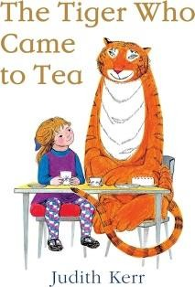 | slurping  feast  cautious  suddenly  total  crouch  farewell  arrive  • The Tiger  •The café  • The tiger wants to join the  family at the café. What will he order? | Tale: The Three Little Pigs  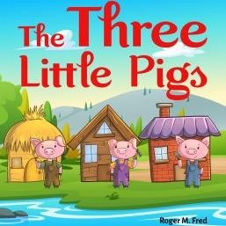 | construct  sturdy  flimsy  taunting  obliterate  scarper  celebrate exhale  - The Big Bad Wolf  - One of the pigs houses  - The wolf has  disguised  himself as a pig…
 | Week 6 |  | Week 7 |  |  | Week 8
 | Past: The Pink Panther  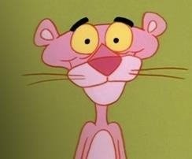 | comical  splodge  clumsy  furious  active  oblivious  reveal  stamp  - Pink Panther  - Pink Panther house  - What might the Pink Panthers friend look like? | Tale: The Magic Porridge Pot 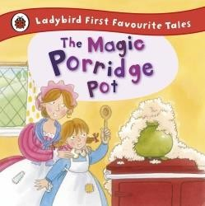 | enchanted  conversation  endless  despair  cease  covered  steaming  gloopy  - The Wizard  - The wizards castle  - The wizards is making potions- what might he put in? | Book: Elmer  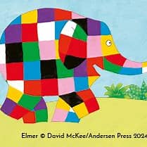 | unnoticed  glum  hilarious  sneakily  unique  content  camouflaged  helpless  - Elmer  - The jungle  - What might Elmers next prank be?
 |  |  |  | Autumn 2
 |  | Week 1 |  | Week 2 |  | Week 3 |  | Week 4
 | Book: Room on the Broom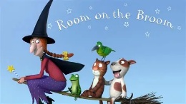 | whoosh  splat  scaly  horrible  passenger  addition  fiery  swoop  - The dragon  - The swamp  - The witch wants a new super fast broomstick | Tale: Hansel and Gretel  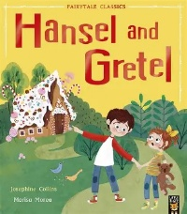 | confectionary  wicked  double  scary  cauldron  swish  piercing  innocent  - The witch  - The witch’s  house of sweets  - Trick or treat? What’s in the pot? | Past: Pingu  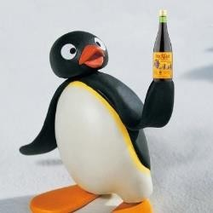 | random mischievous, disappointed,  injured  gobbling  nursed  - Pingu  - The Igloo  - What might Pingu catch? | Book: Stickman  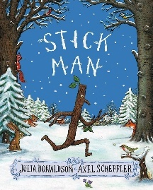 | content  active  enthusiastic  sailing  longing  mast  boomerang  weary  - Stickman  - The tree house  - What else could Stickman be used for?
 |  | Week 5 |  | Week 6 | Week 7
 | Past: The Grinch  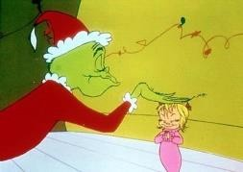 | miserable  cruel  greedy  spoil  sport  - The Grinch  - The Grinch’s House  - The Grinch needs a vehicle to travel around and steal all the Christmas presents- what might he use? | Tale: The Gingerbread Man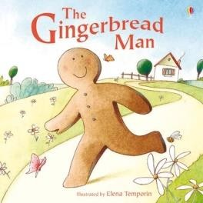 | leap  accelerate  pursue  block  cunning  soggy  mocking  disappointed  - Gingerbread man  - The river  - The old woman  baked a new character | Book: Father Christmas  Comes Up Trumps – Nicholas  Allan   | rumble  bursting  journey  gassy  - Santa  - Santa’s sleigh  - A machine to suck up Santa’s trumps

Spring 1
Week 1 |  | Week 2 |  | Week 3 |  | Week 4
Past: Wacky Races  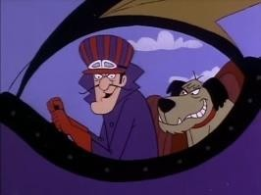 | accelerate  braking  hazard  steering  chuckle  demolish  overtake  transport  - A mascot from the race  - New Vehicle for race  - What will the winner of the race win? | Book: The Gruffalo’s Child by  Julia Donaldson  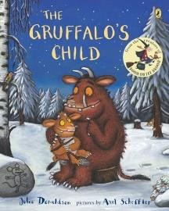 | gigantic  camouflage  petrifying,  ravenous  cautious  daring  - Big bad mouse  - Gruffalo’s Cave  - Midnight feast for the Gruffalos child - what might she eat?  - What might the Gruffalo be dreaming about? | Tale: Chicken Licken  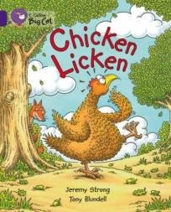 | devoured  crafty  royal  parading  smirking  guillable  hysterical  trickery  - The Fox  - The Sky- whats up there? Put something there that shouldn’t be there.  - The fox is coming to school how will we stop him?  We’re going to shrink ourselves so the fox can’t see us- What will the shrinking machine look like? | Past: Road Runner  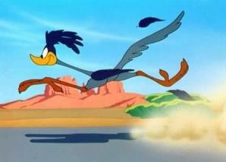 | zooming  patient  ambush  boulder  speedy,  accident  escape  - Road Runner  - Where does the coyote live?  - The coyote wants to travel super fast what might he travel on?  The coyote wants to trick the road runner with something to eat- what might he leave out for him?
Spring 1
Week 5
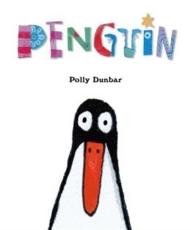 | Book: Penguin – Polly Dunbar  nibble  adore  communicate  companion  - The Lion  - Where does the Lion Live?  - Lion is still hungry what can we give him to eat?  - Where can we hide from the Lion?
Spring 2
Week 1 |  | Week 2 |  | Week 3 |  |  | Week 4
Tale: Jack and the Beanstalk  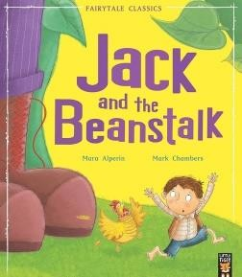 | clambering  booming  ginormous  chopping  - The Giant  - The Beanstalk  - The magic beans bag- what else might be in it?  - Jack and the Giant become friends what might they do together? | Past: Bananaman  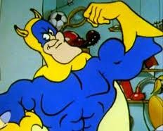 | gloomy  Conniving  victorious  transformation  - Bananaman  - Dr Glooms House  - Invent a place to keep the Bananas  Safe for Bananaman  - Dr Gloom has invented a ray gun what will it turn Banaman into? | Book: What the ladybird heard.  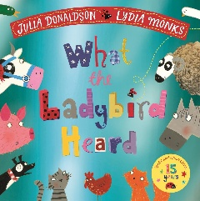 |  | hefty  lanky  cunning  underestimate  overhears  outsmart  - Ladybird  - Farm  - The robbers are going to steal something else. What could it be? | Tale: Ugly Duckling  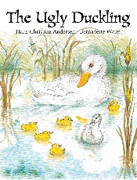 | transform  unwanted  belong  accepted  hatch  dashing  Ugly duck  The river/pond  What could the little chick turn into?
 |  | Week 5
 | Past: Chitty Chitty Bang Bang  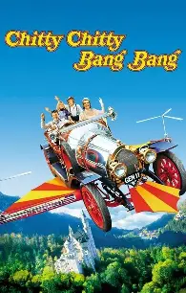 | Exhausting  Reveal  Transformation  Heave  The Garage  The car  What could Chitty transfor-m into?

 |  | Summer 1
Week 1 |  | Week 2 |  | Week 3 |  | Week 4
Book: Supetato – Sue Hendra 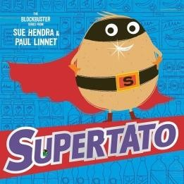 | heroic  nemesis  chaotic  mission  - Supertato  - Evil Peas lare  - SuperTato gets a new vegetable/fruit friend who might it be?  - How might SuperTato catch Evil Pea? | Tale: The Little Red Hen  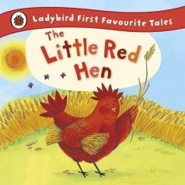 | baking  ingredients  rising  unhelpful  grind  selfish  - The Little Red Hen  - The Farm  - What disgusting thing might the Little Red Hen put on her bread?  The smell of the bread has attracted a bad character who might it be? | Past: Poddington Peas  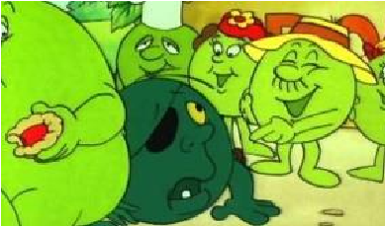 | champion  explode  flourish  cultivate  - Our Favourite Pea  - Poddington- Bottom of the Garden  - A vegetable feast | Book: Bear hunt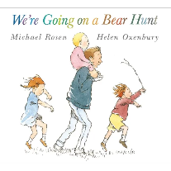 | wandering  joyful  obstacle  courageous  tiptoe  panic  flee  hide  - The bear  - The bear’s  cave with its furniture  - The bear is  coming  back to get  through the  upstairs  window –  how can it get up?
 | Week 5 |  | Week 6
Tale: The Enormous Turnip  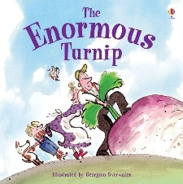 | enormous  root vegetable  attention  harvest  strength  effort  celebrated  - The turnip  - The field  - The turnip will not come out what machine could we use to pull it out? | Past: Rosie and Jim (water)  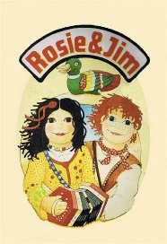 | Past:  - Soaked/soaking  - Float  - Wedged  - Drifting  - Concertina  - Narrowboat  Rosie and Jim  The narrow boat  Where will Rosie and Jim go on their adventure? What mischief will they cause?
 |  |  | Summer 2
 | Week 1 |  | Week 2 |  | Week 3 |  | Week 4
Book: Superworm – Julia Donaldson  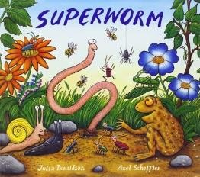 | zooming  transform  wriggling  heroic  - Superworm  - Superworm Base  - A Monster is coming- I wonder what it looks like?  Invent a way Superworm will trap a Monster | Tale: The Elves and the Shoe maker  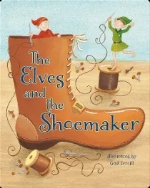 | unexpected  determination  despair  crafting  thrive  generosity  joy  - The elves  - The back of the shop  - What other ways could the elves help someone? | Past: Popeye  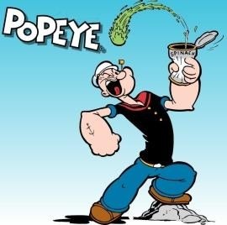 | muscular  crush  gulp  rapid  - Popeye  - The Spinach can factory  - What would be too heavy for Popeye to lift?  - Bluto has set fire to the factory how could Popeye put it out? | Pirate Pete by pirate Pete  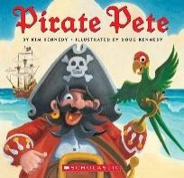 | peer  adventuring  polka dot  cutlass  voyage  ocean  navigate  directions  - Pirate Pete  - Pirate Pete’s boat  - Pirate Pete needs a  crew. who will join him?
 | Week 5 |  | Week 6
Tale: Stone Soup  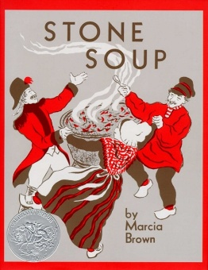 | ingredients  liquid  preparing  suspicious  delicious  warming  vital  - The old man  - A fire in the village  - The man is making a soup, what will he put in? | Past: Magic Roundabout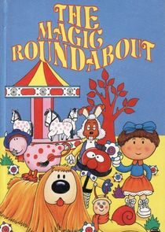 | shy  arrive  pacing  greeting  agitated  in a huff racing  - Zebedeee  - where does Mr rusty live?  - The bubbles are broken! Can we  invent a bubble machine?

