Class 2 Spring 1 Homework Grid
Please complete a Reading and a Times-Tables activity 4/5 times per week:
Reading  The most important thing is to enjoy what you are reading. Over the following weeks, find a fascinating character, find a new word and use it in your own writing, find a new phrase and use it in your writing, find a funny fact, find something amazing, read out a fact to read to the class. Write these down in this book.   | Times Tables  Do as many Times Tables Rock Star activities as you can
Each week choose one of the following activities to complete in your homework book. (You do not need to complete them all) Homework is due in on Mondays please. I really look forward to seeing what you come up with!!
History  - Create a stone age painting  - Make a model of Stonehenge. What materials will you use? Lego, junk modelling, stones etc.  Write a diary entry from a child who lived in the Stone Age. Describe your day.  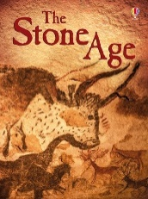 | English  Y3/4 Write a paragraph about a sabre-tooth tiger and include 3 similes.  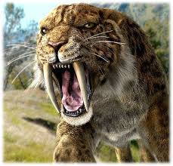  Y5/6 Write 2 paragraphs about a sabre-tooth tiger and include 3 metaphors.
RE Y3/4/5/6  Choose a parable from the Bible. Can you write a modern day version?  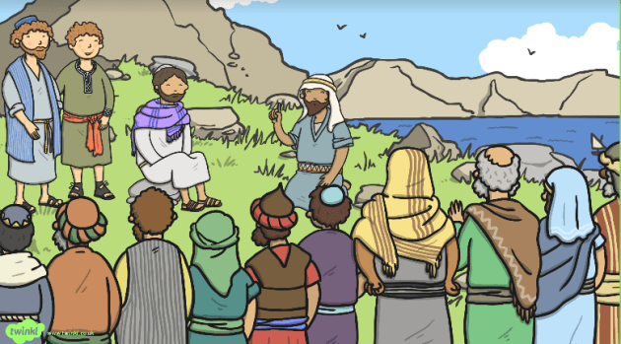 | Science  Y3/4 How many forces can you list when playing on a playground?  Y5/6 Find 3 facts about Isaac Newton
PE  Make up a dance to your favourite song.  Perform it to the class. | Art  Make a piece of artwork which includes a butterfly which is camouflaged.

