Class 2 Summer 1 Homework Grid
Please complete a Reading and a Times-Tables activity 4/5 times per week:
Reading  The most important thing is to enjoy what you are reading. Over the following 6 weeks, read up to 2 books and present a simple book review in class. Also – for Y6 - learn as many spelling patterns as you can from your revision books in preparation for SATS.   | Times Tables  Do as many Times Tables Rock Star activities as you can
Each week choose one of the following activities to complete in your homework book. (You do not need to complete them all) Homework is due in on Mondays please. I really look forward to seeing what you come up with!!
History  Choose a Windrush figure, such as:  - Sam King  - Norma Best  - Lord Kitchener  - Claudia Jones  Research their life and create a fact file.  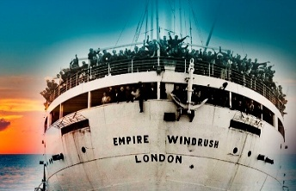 | English  Y3/4 Write a paragraph about 1 member of the Artemis II crew.    Y5/6 Write 2 paragraphs about 2 members of the Artemis II mission.  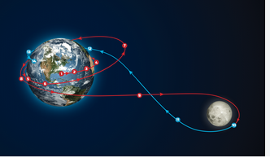
RE  Yr 3/4 Make a list of people who have authority in your life and in this country.  e.g. Parents, teachers, policemen, the King!  Create a collage with pictures.  Yr 5/6  Who inspires you and why? Draw and write about them.  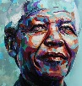 | Science - LIGHT  Y3/4 Name and draw 4 natural light sources  Y5/6 Draw a scientific labelled diagram  of the eye.  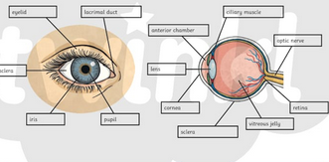
French  Y3/4 Draw and label a fruit bowl in French.  Y5/6 Create a healthy fruit salad menu in French | Art  Class 2 Design a Table mat using Kente fabric patterns and colours

