Class 2 Spring 2 Homework Grid
Please complete a Reading and a Times-Tables activity 4/5 times per week:
Reading  The most important thing is to enjoy what you are reading. Over the following weeks, research a topic that really interests you using non-fiction texts - on line included. Present 3 amazing and awesome facts about your chosen topic. You could even try your own power-point and email it to me via Class Dojo. I look forward to hearing and reading what you find out.   | Times Tables  Do as many Times Tables Rock Star activities as you can
Each week choose one of the following activities to complete in your homework book. (You do not need to complete them all) Homework is due in on Mondays please. I really look forward to seeing what you come up with!!
Geography  Research a country which has Fairtrade links. Create a poster all about fair trade! Here are some questions to help you:  What is Fairtrade? What are the impacts when buying Fairtrade products? What Fairtrade products does your chosen country produce? How does Fairtrade benefit farmers and workers? How do you buy Fairtrade products?  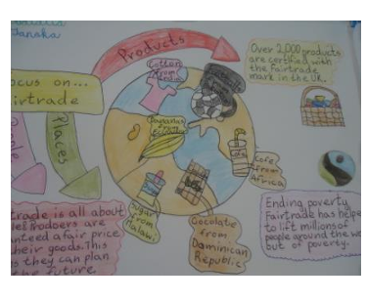 | English  Y3/4 Find 5 facts about Ernest Shackleton  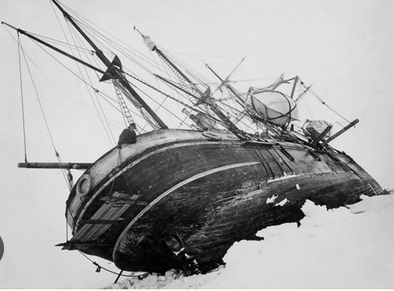  Y5/6 Write a character profile about Ernest Shackleton  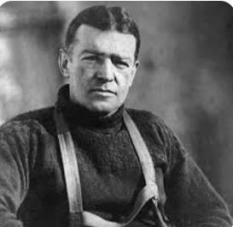
RE Y3/4/5/6  Create a piece of art work based on Jesus and the Easter Story.  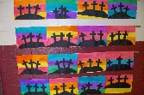 | Science  Y3/4 Name 4 occupations where knowledge and understanding of electricity are really important.  Y5/6 Find out where we get the words Volt and Watt from.
DT Y3/4/5/6
Make a simple casing for a nightlight from recycled materials to which you can add an electrical circuit in school.

