Class 2 Spring 1 Homework Grid
Please complete a Reading and a Times-Tables activity 4/5 times per week:
Reading  The most important thing is to enjoy what you are reading. Over the following weeks, find a fascinating character, find a new word and use it in your own writing, find a new phrase and use it in your writing, find a funny fact, find something amazing, read out a fact to read to the class. Write these down in this book.   | Times Tables  Do as many Times Tables Rock Star activities as you can
Each week choose one of the following activities to complete in your homework book. (You do not need to complete them all) Homework is due in on Mondays please. I really look forward to seeing what you come up with!!
History  - Create a stone age painting  - Make a model of Stonehenge. What materials will you use? Lego, junk modelling, stones etc.  Write a diary entry from a child who lived in the Stone Age. Describe your day.  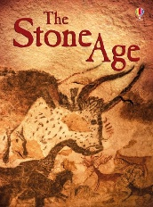 | English  Y3/4 Write a paragraph about a sabre-tooth tiger and include 3 similes.  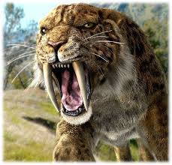  Y5/6 Write 2 paragraphs about a sabre-tooth tiger and include 3 metaphors.
RE Y3/4/5/6  Choose a parable from the Bible. Can you write a modern day version?  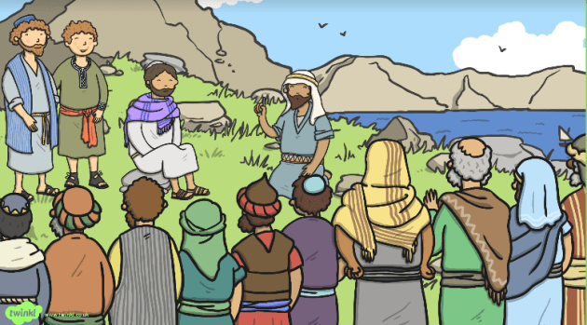 | Science  Y3/4 How many forces can you list when playing on a playground?  Y5/6 Find 3 facts about Isaac Newton
PE  Make up a dance to your favourite song.  Perform it to the class. | Art  Make a piece of artwork which includes a butterfly which is camouflaged.

Class 2 Autumn 1 Homework Grid
Please complete a Reading and a Times-Tables activity 5 times per week:
Reading  The most important thing is to enjoy what you are reading. Over the following weeks, find a fascinating character, find a new word and use it in your own writing, find a new phrase and use it in your writing, find a funny fact, find something amazing, read out a fact to read to the class. Write these down in this book. | Times Tables  Do as many Times Tables Rock Star activities as you can
Each week choose one of the following activities to complete in your homework book. (You do not need to complete them all) Homework is due in on Mondays please. I really look forward to seeing what you come up with!!
Geography  Y3/4 Name and locate at least 10 countries in Europe by heart.  Y5/6 Name and locate at least 10 countries in Europe by heart and name their capital cities. 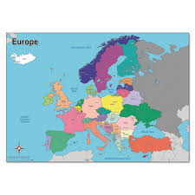 | English  Y3/4 Draw a picture of a setting - your own Enchanted woodland where you will set your story for your book for Class 1.  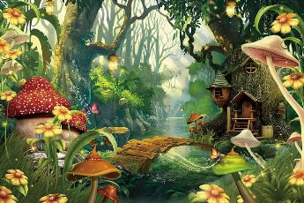  Y5/6 Draw a picture of a setting - your own Rainforest where you will set your adventure story to read to Y3 and 4.  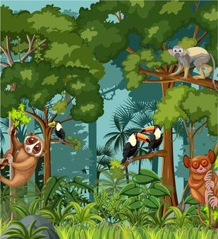
RE Y3/4/5/6  Write a prayer that would be suitable to read in church at the Y6 Leavers service.  Create your own prayer space at home, | Science  Y3/4 Draw some desert plants and animals.  Y5/6 Explain to your parents what the letters MRS GREN stand for in relation to living things.
PE  Take a photo of you playing out and make a list of the ways you stay safe during the games or activity you are doing. | DT Y3/4/5/6  Make your own Frittata or Moussaka at home changing the recipe for your own preferences – recipes attached.
Class 2 Autumn 1 Homework Grid
Please complete a Reading and a Times-Tables activity 4/5 times per week:
Reading  The most important thing is to enjoy what you are reading. Over the following weeks, find a fascinating character, find a new word and use it in your own writing, find a new phrase and use it in your writing, find a funny fact, find something amazing, read out a fact to read to the class. Write these down in this book. | Times Tables  Do as many Times Tables Rock Star activities as you can
Each week choose one of the following activities to complete in your homework book. (You do not need to complete them all) Homework is due in on Mondays please. I really look forward to seeing what you come up with!!
History  Y3/4 Name and locate at least 10 countries in Europe by heart.  Y5/6 Name and locate at least 10 countries in Europe by heart and name their capital cities. | English  Y3/4 Create a poster for the classroom to encourage us to reduce food waste and  be a food waste warrior 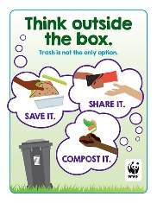  Y5/6 Create a poster for the classroom to encourage us to reduce, re=use and recycle. 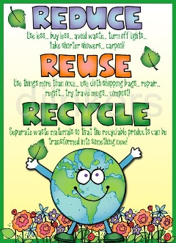
RE Y3/4/5/6  Write a prayer that would be suitable to read in church at the Y6 Leavers service.  Create your own prayer space at home, | Science  Y3/4  Y5/6 Draw and label the life cycle of
Music  Ask your | DT Y3/4/5/6  Make your own Frittata or Moussaka at home changing the recipe for your own preferences – recipes attached.

